# CS-340 Dashboard Project README

## About the Project/Project Title

*This project implements an interactive web-based dashboard for an animal shelter using Dash and MongoDB. The dashboard displays animal rescue data and provides various visualizations, such as breed distributions and geolocation maps, based on user-defined filters.*

## Motivation

*The goal of this project is to create an interactive dashboard for an animal shelter system, allowing users to filter, view, and analyze data related to animal rescues.* *This project aims to provide an effective solution to visualize and interact with shelter data, improving decision-making and operational efficiency for animal rescue organizations.*

## Getting Started/Installation

* *Python 3.6*
* *MongoDB (ensure that the MongoDB service is running and accessible)*
* *Required Python Libraries:*
* *dash*
* *dash-leaflet*
* *plotly (https://dash.plotly.com/)*
* *pymongo (*[*https://pymongo.readthedocs.io/en/stable/*](https://pymongo.readthedocs.io/en/stable/)*)*

## Walkthrough

*As per Grazioso Salvare’s request, the dashboard has a few main components:*

* *Logo with link to their website*
* *A data table that has custom filters and sorting, containing the data from the Austin Animal shelter database*
* *Custom prebuilt filters that filter for specific needs like-*
* *Water Rescue*
* *Mountain Rescue*
* *Disaster Rescue*
* *Pie chart that updates with filters to show available breeds*
* *Map with location of selected animal*

*The pre-built filters that are provided by the client are as follows:*

When the user selects any of these pre-built filters, the table and the pie chart are updated:



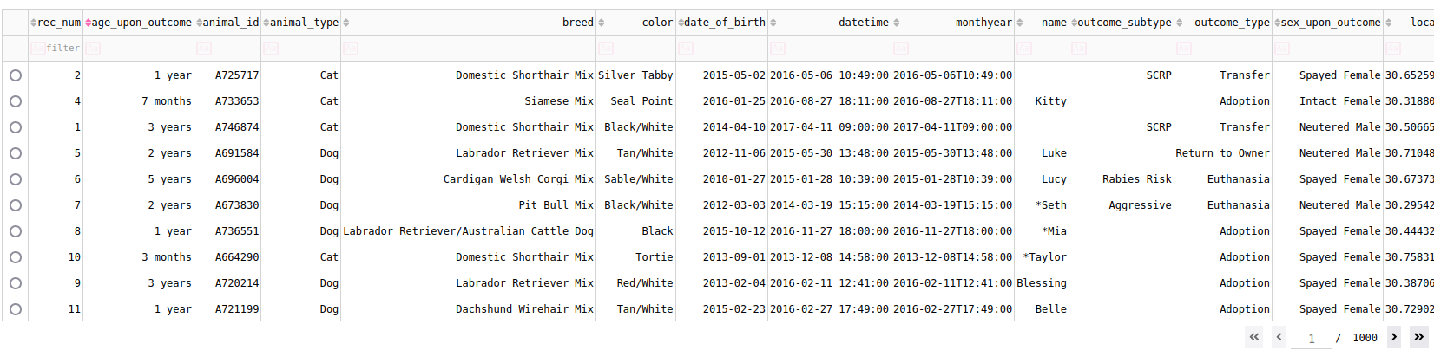



If a specifc animal is selected then the animal’s location will be displayed on the map:

While an animal is selected, hovering over the location on the map displays the animal name:

## Conclusion

This project demonstrates the power of interactive data visualization to improve the accessibility and usability of animal shelter data. By filtering and analyzing animal information, rescue organizations can make more informed decisions, ultimately benefiting the welfare of animals.